
LAB EXPERIMENT-02
Program: B. Tech
Academic Year / Yr-Sem: 2025--26 [EVEN Sem]
Course Title & Code: FULL STACK APPLICATION DEVELOPMENT-[24SDCS02]
- Student ID = 2400080050
- Name = K Bhuvana Siri
- Skill Experiment Number: 02
- Section Number:01

CODE:
Dependencies Addition in pom.xml file:
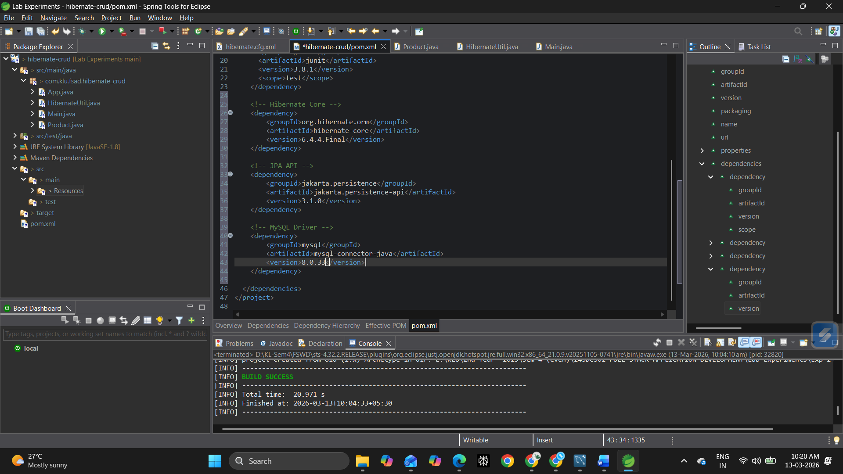

Hiberenate.cfg.xml
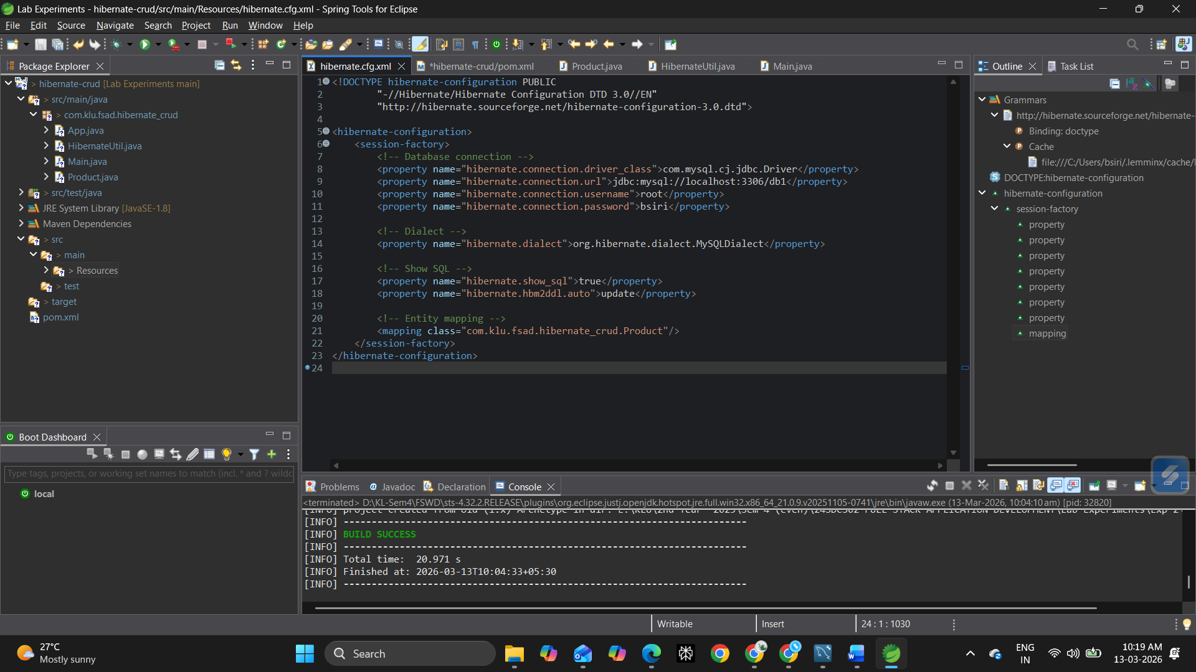
Product.Java
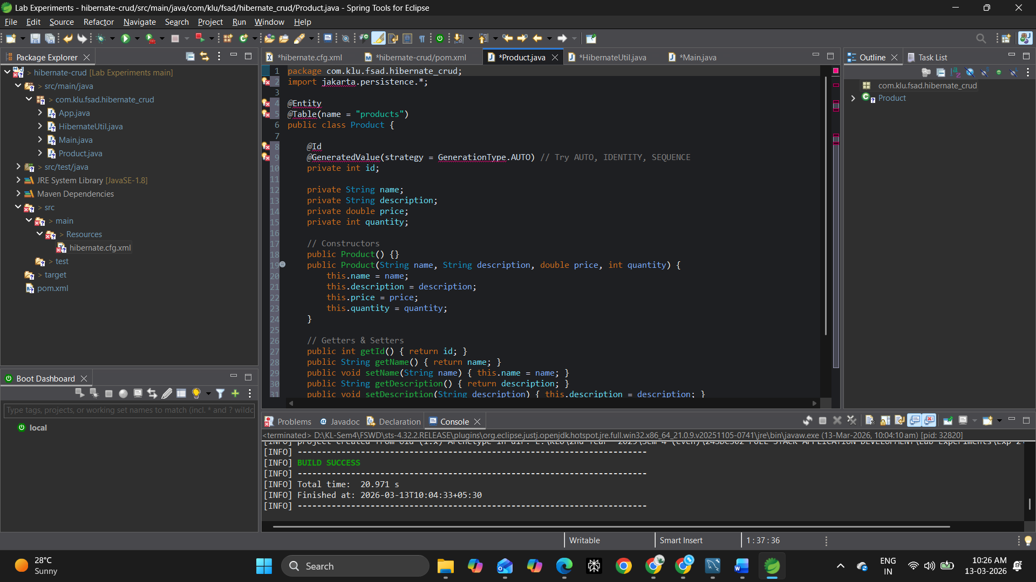

Hibernateutil.java
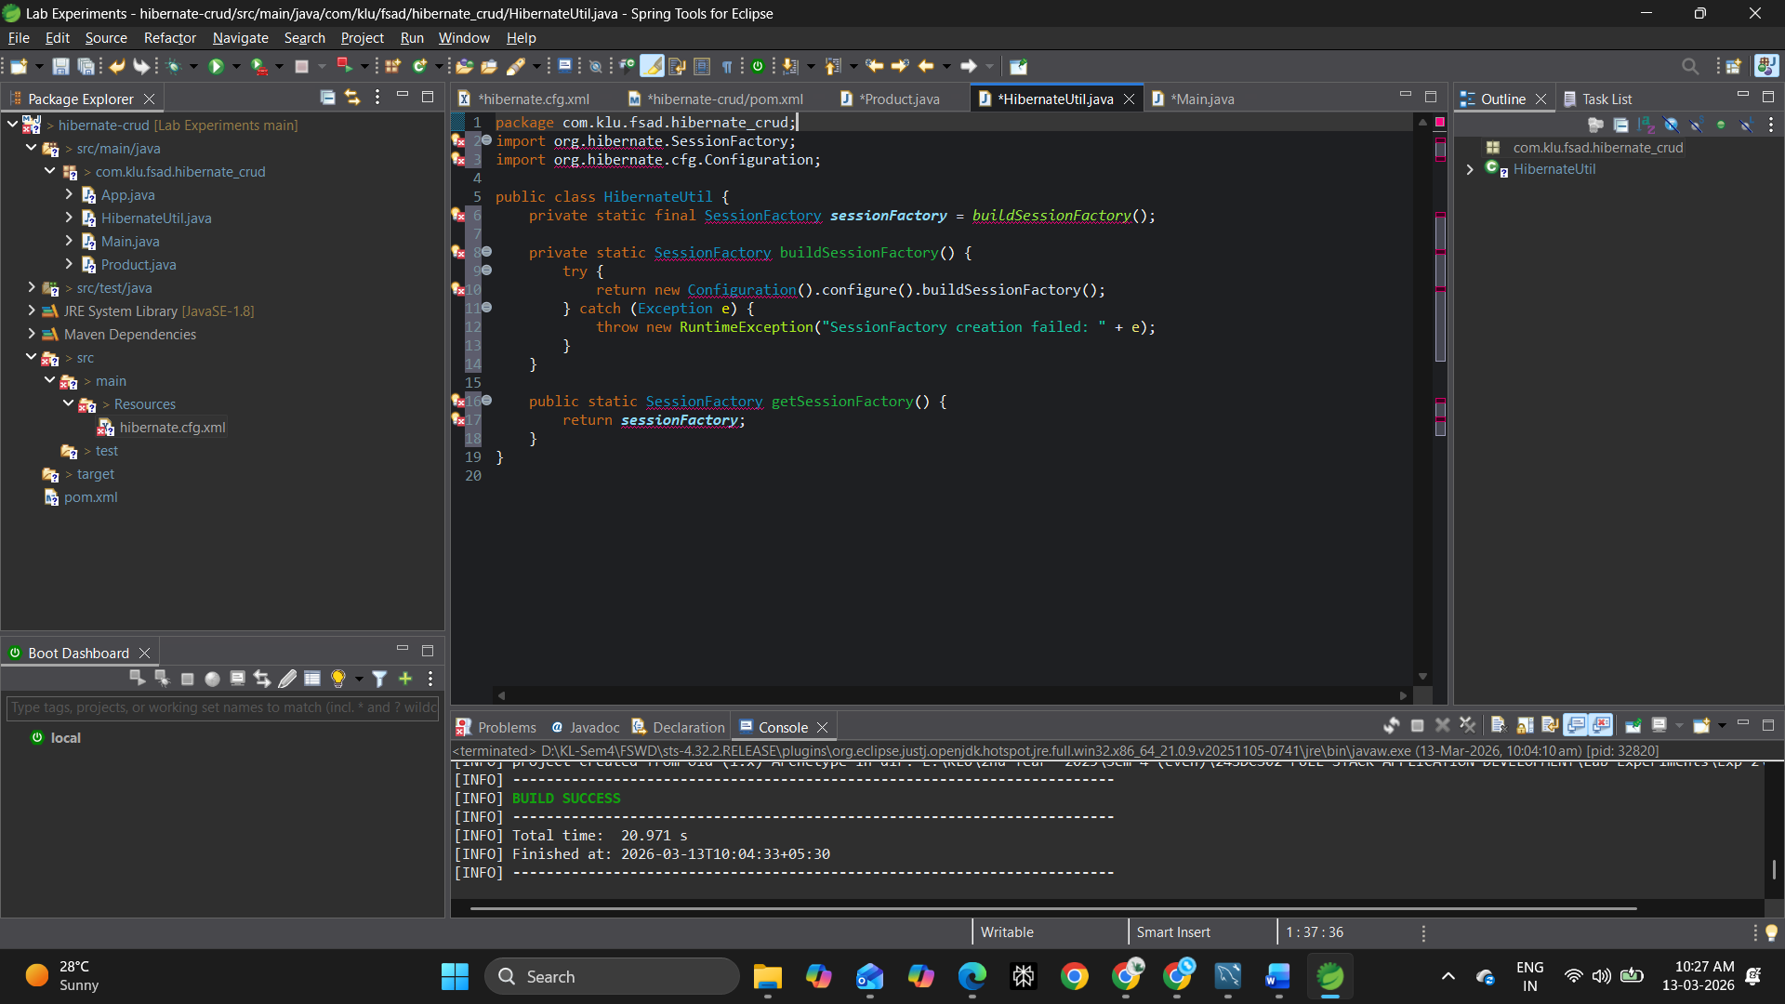
Main.java:
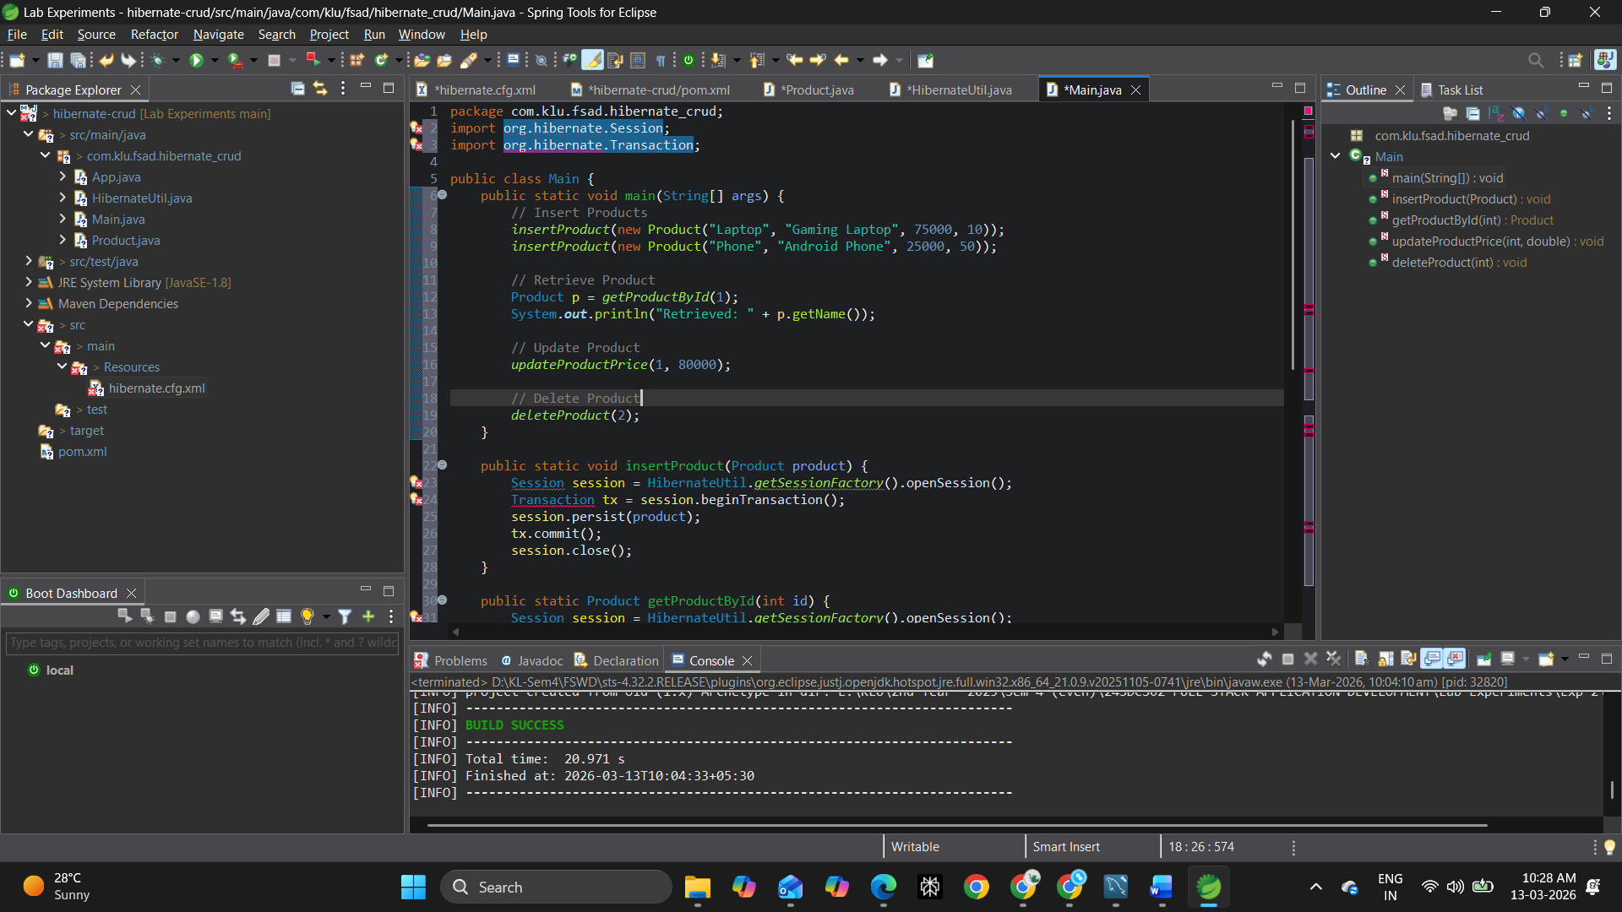

Data Base Creation:
